
Anatomy & Physiology Part One Exam
Please read these instructions before you begin to answer the questions that follow.
You are welcome to work your answers on this paper examination for your convenience. You will submit your final answers through an uploaded file through our app. When you are satisfied that your answers are correct, use the app to download an instruction file for the corresponding lesson. This will open the lesson, so you are able to add your work for grading. Complete this file upload for grading. Only the answers on the submitted file will be considered for grading.

You have reached the end of Part 1 and are ready for your Part 1 Examination. After you complete it, log in and submit through the app. Good luck!

Instructions:
Follow the instructions for each question. Show your work in the space provided and write the answer on the line. You will need to show your work on the file submitted to your teacher for grading.
Multiple Choice (worth 2 points each): Enter your selected answer into the blank space provided.

_____1. Which of the following is not a unit in the metric system?
  - meter
  - liter
  - Celsius
  - second

_____2. Which of the following is made of organized groups of molecules that perform a special function?
  - atoms
  - organs
  - tissues
  - cells

_____3. Which of the following is an example of positive feedback?
  - shivering
  - sweating
  - pH increase
  - blood clotting

_____4. A tissue is said to be ________ when a force is removed and the object returns to its normal shape.
  - plastic
  - torqued
  - efferent
  - elastic

_____5. A player gets hit by a lacrosse ball. What is the predominant type of force generated by the ball on the player?
  - compressive stress
  - tensional stress
  - shear stress
  - transform stress

_____6. The tail of a phospholipid is ______________.
  - hydrophilic
  - made of linked amino acids
  - hydrophobic
  - “water loving”

_____7. Each of the following is a component of RNA EXCEPT
  - ribose
  - thymine
  - adenine
  - sugar-phosphate

_____8. ATP is similar to DNA because each one contains _____________.
  - an adenine base.
  - a sugar phosphate complex.
  - a double helix shape.
  - both a and b.

Use the image below to answer questions 9-10.

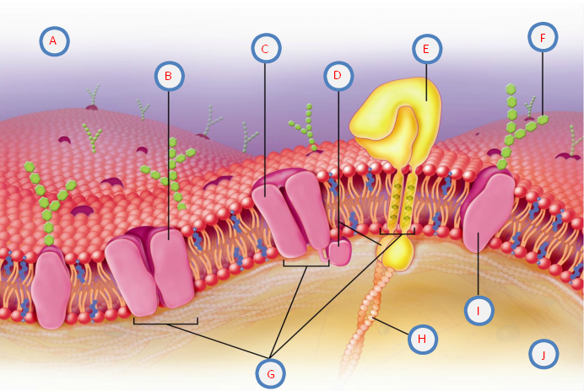

_____9. Which of the structures labeled above allows particles to passively pass through the plasma membrane?
  - C
  - F
  - E
  - I

_____10. The structure labeled F is responsible for communicating with the immune system. The ______________________ helps identify cells as self or non-self.
  - channel protein
  - protein pump
  - carbohydrates
  - glycoprotein

_____11. Which connective tissue provides support for the body?
  - cartilage
  - bone
  - blood
  - adipose

_____12. What is the function of synovial fluid?
  - provides support to a joint
  - gives cushion and reduce friction
  - resists stretching
  - offers elasticity

_____13. The ___________ glands are found in the _________ and start functioning at puberty.
  - sudoriferous, dermis
  - merkel cell, stratum basale
  - apocrine, armpit
  - sebaceous, skin

_____14. True or False: Psoriasis is a highly contagious disease characterized by scaly skin patches that itch, burn, crack, and sometimes bleed.
  - True
  - False

_____15. True or False: Keratin is responsible for human skin color.
  - True
  - False

_____16. An osteon is composed of which of the following?
  - perforating canals
  - lacunae
  - Haversian canal
  - both B and C

_____17. What is responsible for bone lengthening in adolescents?
  - epiphyseal plates
  - ossification
  - bone marrow
  - epiphyses

Use the image below to answer questions 18-20.
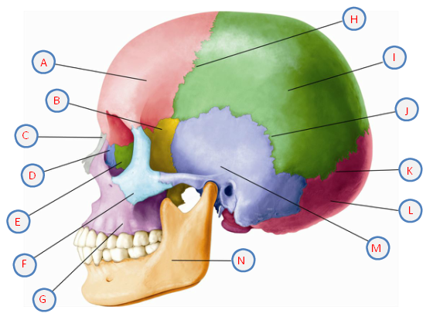

_____18. Which structure labeled above is also known as the cheekbones?
  - E
  - F
  - G
  - H

_____19. The structure labeled N above is the ____________ and the only movable facial bone.
  - maxillary bone
  - palatine bone
  - mandible
  - nasal bone

_____20. Which of the following cranial bones are paired?
  - parietal
  - frontal
  - occipital
  - ethmoid

_____21. Which structures are part of the appendicular skeleton?
  - the head and trunk
  - the spinal column
  - the arms and legs
  - none of the above

_____22. Another term for freely moveable joints is______________.
  - synarthroses
  - amphiarthroses
  - synovial joints
  - symphyses

_____23. What autoimmune disease results in the body attacking healthy joint tissues?
  - diabetes type i
  - rheumatoid arthritis
  - thyroiditis
  - hepatitis

_____24. Which nervous system controls smooth muscle movement?
  - central
  - autonomic
  - somatic
  - muscular

_____25. What chemical diffuses across the synaptic cleft when a nerve impulse reaches the axon terminal?
  - tetanus
  - neuroglia
  - acetylcholine
  - epinephrine

_____26. Tendonitis is to tendon as ___________________________.
  - conjunctivitis is to cornea
  - rhinitis is to mucous membrane
  - tinnitus is to auditory canal
  - external otitis is to tongue

_____27. The oblique muscles can be found ________________________.
  - on the anterior trunk
  - posterior to the rectus abdominis
  - on the lower limbs
  - around the elbow

_____28. Which of the following is NOT true regarding action potentials in nerve impulses?
  - the inside of the membrane as an overall negative charge
  - potassium ions are found inside the cell
  - negative sodium ions are outside the cell
  - the cell membrane is polarized

_____29. True or False: The primary motor cortex sends messages that control muscle movement and can be found anterior to the central cortex.
  - True
  - False

_____30. The autonomic nervous system connects to the central nervous system and controls which areas of the body?
  - heart
  - smooth muscles
  - glands
  - all of the above

_____31. What part of the eye is considered “the white of the eye?”
  - choroid
  - sclera
  - cornea
  - iris

_____32. What part of the eye narrows or widens the pupil in response to changes in light?
  - sclera
  - cornea
  - retina
  - iris

_____33. True or False: Blindness can be caused by long term diabetes.
  - True
  - False

_____34. What does the ceruminous gland secrete?
  - tears
  - earwax
  - sweat
  - mucous

_____35. Which of the following is not an example of an exocrine secretion?
  - sweat
  - saliva
  - estrogen
  - breast milk

_____36. In a negative feedback loop, what is the next step that follows the hypothalamus and pituitary glands directing the target gland to release hormones?
  - target gland sends signals to the hypothalamus and pituitary glands
  - they hypothalamus inhibits the construction of hormones
  - the loop starts back again
  - the target gland releases the hormones and achieves the goal

_____37. What happens when blood glucose levels drop?
  - the pancreas stimulates the production of glucagon
  - the liver converts glucose to fat
  - glucose is taken up into the cells
  - none of the above

_____38. What regulates calcium in the body?
  - thyroid
  - parathyroid
  - thymus
  - both A and B

_____39. The symptoms of what disorder include excessive urination, excessive thirst, and increased hunger?
  - Addison’s disease
  - diabetes mellitus
  - muscular dystrophy
  - hypothyroidism

_____40. ______________ glands have ducts and are the counterpart of the endocrine glands.
  - Glucagon
  - Peripheral
  - Exocrine
  - Central

Essays (worth 20 points, 10 points each)

41. Describe the types of neurons, their structure and their function.

______________________________________________________________________________

______________________________________________________________________________

______________________________________________________________________________

______________________________________________________________________________

______________________________________________________________________________

______________________________________________________________________________

______________________________________________________________________________

______________________________________________________________________________

______________________________________________________________________________

______________________________________________________________________________

______________________________________________________________________________

______________________________________________________________________________

______________________________________________________________________________

______________________________________________________________________________

______________________________________________________________________________

______________________________________________________________________________

______________________________________________________________________________

______________________________________________________________________________

______________________________________________________________________________

______________________________________________________________________________

______________________________________________________________________________

______________________________________________________________________________

42. Many of the molecules found in the body are organic.
A: Make an argument for which three biological molecules you feel are the most important for the body. B: Water is inorganic but still essential. Could humans live without water? Why or why not?
______________________________________________________________________________

______________________________________________________________________________

______________________________________________________________________________

______________________________________________________________________________

______________________________________________________________________________

______________________________________________________________________________

______________________________________________________________________________

______________________________________________________________________________

______________________________________________________________________________

______________________________________________________________________________

______________________________________________________________________________

______________________________________________________________________________

______________________________________________________________________________

______________________________________________________________________________

______________________________________________________________________________

______________________________________________________________________________

______________________________________________________________________________

______________________________________________________________________________

______________________________________________________________________________

______________________________________________________________________________

_____________________________________________________________________________

